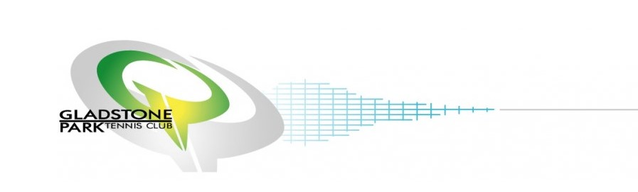

Gladstone Park Junior Tennis Tournament

23rd, 24th & 25th January 2018

To be played at:
Gladstone Park Tennis Club (9 Synth Clay Courts)
18 Elmhurst Rd, Gladstone Park, Mel Ref: 6 A11

Tournament Mobile: 0418 178 328
Club Phone: 9338-7851

Post Entries to: Enquiries to:
Gabriel Moise Gabriel Moise
P.O. Box 2187 Tournament Manager
Prahran Vic 3181 Mobile: 0418 178 328
Cheques must be payable ttpt@optusnet.com.au
to Gabriel Moise

Entries close: 20th January 2017

Draws Available: January 22nd 2018

2018 Gladstone Park Junior Tournament Entry Form
First Name: ______________________ Surname: ___________________

Address: _____________________________________ Postcode: _____

Suburb: ___________________________________________________ Phone: ______________________________

Date of Birth: ________________ Age in 2018: _____________________ Email:_____________________________

Your ITN? : _________________ Club: ______________________________ Grade: _________________________

Note: Age restrictions: players in boys and girls events must be born 1999 or later.
Number of events: A maximum of 4 events per entry with a maximum of 2 singles events.

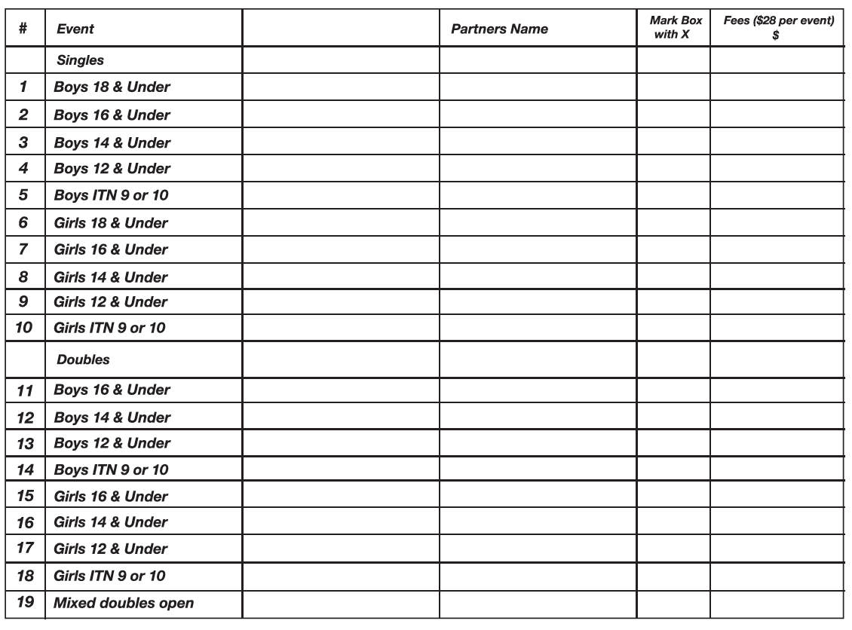
Please accept my entry for the above event(s) for which I enclose fees of $____________.

I have not entered any other tournament from the 23rd to 25th of January 2018 and I agree to abide by the Tournament conditions and the Tennis Australia code of conduct.

Player Signature: ______________________________________ Post entries to: Gabriel Moise, P.O Box 2187 Prahran Vic 3181

Entry fees must accompany entry form. Please make cheques payable to Gabriel Moise.

Sponsored by

